David L. Suddjian
Biological Consulting Services

801 Monterey Avenue, Capitola, CA 95010
Telephone 831· 479· 9603, email dsuddjian@aol.com

Summary of 2006
Marbled Murrelet Monitoring Surveys

In The Santa Cruz Mountains

Prepared for

Command Oil Spill Trustee Council

Prepared by

David L. Suddjian
Biological Consulting Services
801 Monterey Ave., Capitola, CA 95010

January 2008
Final Report

INTRODUCTION

This report presents the results of Marbled Murrelet (Brachyramphus marmoratus, hereafter referred to as “murrelet”) monitoring surveys conducted in 2006 for the Command Oil Spill Trustee Council (COSTC) in the Santa Cruz Mountains at Big Basin Redwoods State Park, Portola Redwoods State Park, Butano State Park, and San Mateo County Memorial Park (Figure 1). These surveys were commissioned to assist the COSTC in restoration planning for potential projects benefiting the Marbled Murrelet.

Methods

Study Design

Dawn surveys were conducted at five stations in Big Basin, and at two stations each in Portola, Butano, and Memorial (Figure 1). Coverage at Butano, Memorial and one of the Portola stations was begun in 2003 to augment an existing long-term program of monitoring already established at Portola (since 1992) and Big Basin (since 1995). Since 2003 each station in each park has been surveyed three times annually from June to July, with two surveys at each in July. Two additional surveys are conducted at one of the Portola stations so that surveys occur there on three consecutive mornings in late June to continue a pattern of coverage begun at that station in 1992. Total annual surveys for each park are 15 at Big Basin, eight at Portola, and six each at Butano and Memorial.

Location of Survey Stations

Criteria for station placement and the selection of sites were described in Suddjian 2004.

The five stations at Big Basin (“Redwood Meadow”, “100 Acre Woods”, “Blooms Creek”, “Huckleberry”, and “Sempervirens”) were established in 1995 in a dispersed array in the upper watershed of the East Fork of Waddell Creek (Figure 2). “Redwood Meadow” station is at the meadow near the beginning of the Redwood Trail. “100 Acre Woods” station is on the North Escape Road at that road’s northern crossing of Opal Creek. “Blooms Creek” station is along East Ridge Trail east of Blooms Creek Campground. “Huckleberry” station is near site #17 in the tent cabins area of Huckleberry Campground. “Sempervirens” station is east of the Sempervirens Reservoir access road, midway between the reservoir and Lodge Road.

At Portola (Figure 3) the “Peters Creek Bridge” station at Portola (established in 1992) is located on the bridge adjacent to the park’s main campground. “Iverson” station (established in 2003) is located where Iverson Trail crosses Pescadero Creek west of park headquarters (Figure 3).

At Butano (Figure 4), “Ben Ries” station (established in 2003) is on the main park road 50 meters before the road enters Ben Ries Campground, adjacent to campsite #1. “Little Butano Creek” station (established in 2003) is at a large landslide along a park service road that begins at the entrance to the campground.

At Memorial (Figure 5), “Sequoia” station (established in 2003) is in the Sequoia Flat Campground where the main camp road enters the “D” section of the camp, adjacent to campsite #D1. “Memorial” station (established in 2003) is at Pescadero Creek adjacent to the Tan Oak Flat Picnic Area, at the site of the “swimming pool” that was formerly created seasonally in the creek.

Dawn Murrelet Surveys

Dawn murrelet surveys followed the standard protocol for audio-visual surveys in forests (Pacific Seabird Group 2003). David Suddjian conducted all the surveys. In addition to the murrelet survey data, all bird species detected were recorded (noting initial time, estimates of numbers, and other pertinent information), and two unlimited distance point counts were conducted during each dawn survey (Appendix 1). The point counts lasted 10 minutes and began at 0-5 minutes and 45 minutes after sunrise. Additional details of observations of Common Ravens (Corvus corax) and raptors (direction, distance, behavior, etc.), and a best estimate of the maximum number of Steller’s Jays (Cyanocitta stelleri) noted during each survey were also recorded.

Seasonal Timing of Coverage

Survey dates for each park in 2006 are given on Table 1. An effort was made to schedule coverage at each station on dates close to survey dates of previous years.

Additional Information on Murrelet Occurrence at Big Basin

Appendix 2 presents a summary of survey results from the Redwood Meadow / Park Headquarters parking lot of Big Basin. A total of 186 surveys following the same methods as those of this study have been completed at this site since 1991, representing the longest unbroken series of data for murrelets from any site in the Santa Cruz Mountains, and offering an opportunity to examine longer-term trends. In 2006 Suddjian conducted 16 additional surveys at the Redwood Meadow / Park Headquarters parking lot area from April 19 to July 23, in addition to the three for the COSTC contract.

Appendix 3 presents a summary of results from a USGS Breeding Bird Survey (BBS) route sampled by Suddjian from 1992 to 2006 that begins at Big Basin. While the BBS method is not specifically designed for monitoring murrelets at forest sites, it does provide a repeated measure of activity, and coverage for the BBS at Big Basin was contemporaneous with the other monitoring efforts presented in this report.

Results

Marbled Murrelet

Dawn flight activity in 2006 is characterized below for each park. Subjective descriptors of “low, “moderate,” and “high” activity refer generally to total detection counts in the range of 0-10 detections, 11-50 detections, and >50 detections, respectively. Results of the 2006 murrelet surveys are shown on Table 1. Tables 2 and 3 compare annual average activity at each station and park.

Big Basin Redwoods State Park

Activity remained very low in 2006 compared to the park’s known history of high activity, continuing the pattern of the most recent years (Suddjian 2003a, 2003b, 2004, 2005a, 2005c), but it was slightly up from 2002-2005 (Table 2, Figures 6 and 7).
The 15 surveys produced 106 total detections and 37 detections of below canopy flights. Five surveys (33%) had no detections at all. Unlike all years since 2001, the expected July peak in activity was evident in 2006. A few detections at Redwood Meadow and 100 Acre Woods suggested intense courtship or local nesting (see below).

The area around “Redwood Meadow” remained a general hub for murrelet flight activity in the East Fork Waddell watershed, but activity was more evenly distributed across available habitat in 2006 than in any year since 2001. Surveys at “Redwood Meadow” in 2006 produced 52% of all detections recorded in Big Basin, and 59% of all below canopy detections. Activity levels ranged from low to moderate (10-29 detections), with 6-15 detections of below canopy flights each survey (Table 1). On July 5 one or more pairs were observed “tail chasing” below the canopy on three detections before sunrise, and one detection (18 min. before sunrise) was of a single bird that appeared to be carrying something (presumably a fish) in its bill as it flew below canopy toward the “Father of the Forest” tree. However, the view was brief and the identity of what it carried remained uncertain.

Activity at “100 Acre Woods” was low to moderate (0-21 detections), with activity recorded on only two of three surveys (Table 1). Nine detections of below canopy flights were recorded on July 20, resulting from intense local flight activity by one pair. These included observations of “tail-chasing” and an observation that suggested the birds were approaching a tree for a landing, but they left view before any landing occurred. A pair was seen circling over the station on the June 20 survey.

Activity at “Huckleberry” was low (4-10 detections), but detections were recorded on all three surveys for the first time since 1998 (Table 1). Most involved murrelets flying up and down the Sempervirens drainage. Murrelets were recorded within 100 m of the station on each survey (most detections from 2001-2005 were of distant birds), and an occupied site behavior on July 18 was only the second occasion such behavior was noted at this station since 1998. Several auditory-only detections on July 6 and 18 were likely also of birds flying below canopy, but they were not seen to confirm the behavior.

Activity at “Blooms Creek” was low (0-8 detections), with murrelets noted on two of three surveys, but there were no detections of below canopy flights (Table 1). Seven of the nine total detections were oriented to the west or northwest or north and involved birds moving up the Blooms Creek drainage and then returning back down. Two detections of birds east or northeast of the station were the first since 2001 to confirm that murrelets were flying up the Blooms drainage eastward past the station. No occupied site detections have been recorded at “Blooms Creek” since July 2001.

“Sempervirens” had no detections on any of the surveys (Table 1). There have been no detections on any of the 15 surveys at “Sempervirens” since activity was last noted there in July 2001.

Trends at Big Basin

Activity levels have remained relatively very low since 2002, following a major drop in activity from levels of the mid-1990s (Table 2; Figures 6 and 7). The long-term decline was significant for total detections (r² = 0.921, p = 0.0002) and occupied site detections (r² = 0.727, p = 0.0017) (Figures 6 and 7). Each station individually exhibited the same general pattern of a decline from relative high activity in the beginning years of monitoring to relative low activity in recent years (Figure 8). Data collected in 2006 from the more extensive series of surveys at Redwood Meadow (Appendix 2) and from the BBS route (Appendix 3) continued to match the pattern of decline documented by this study.

Portola Redwoods State Park

Activity at Portola in 2006 was up slightly from 2005, but remained considerably lower than in 2003-2004 (Table 2, Figures 11-13). There were no observations of particular behavioral interest during any of the Portola surveys.

Activity at “Peters Creek Bridge” was moderate on the three consecutive surveys in late June (16-20 detections), but showed no appreciable increase on the two July surveys (14-25 detections; Table 1). Below canopy flights increased somewhat in 2006, being recorded on four of five surveys at this station. But the frequency of occurrence remained low, with just 1-4 occupied site detections per survey. Patterns of activity around the station were similar to prior years.

Activity at “Iverson” was low to moderate (5-22 detections), with detections of below canopy flights on one morning (Table 1). This relatively low level of activity contrasted strongly with that noted in 2003 and 2004 (Suddjian 2004 and 2005a), when activity at “Iverson” had consistently been among the highest of any station in this study (Table 2).

Trends at Portola

Three Consecutive Mornings at Peters Creek Bridge. The only long term comparison available for Portola is for the surveys conducted on three consecutive mornings in late June at “Peters Creek Bridge” (Table 3). Activity in 2006 was the lowest yet recorded for that effort, both for total detections and occupied site detections, but was only slightly lower than activity in 2003 to 2005 (Table 3, Figure 9). Linear regression on average total detections over the whole period of 1992-2006 showed a significant declining trend (r² = 0.408, P = 0.017; Figure 10). The declining trend for occupied site detections was non-significant over the whole period of 1992-2006 (P = 0.176), but was significant from 1995 onwards (r² = 0.653, p = 0.008).

Entire Season. Average detections from Portola stations over the entire survey season in 2006 were similar to those of 2005, with both years down dramatically from 2003-2004 for both total detections (Figure 11) and occupied site detections (Figure 12). The four-year period 2003-2006 showed a significant decline in total detections (r² = 0.812, P = 0.049), and a marginally significant decline in occupied site detections (r² = 0.7677, P = 0.062). The decrease at both stations is shown on Figure 13.

Butano State Park

Activity at “Ben Ries” ranged from low to moderate (3-22 detections), with below canopy flights recorded on one survey (Table 1). As in prior years (Suddjian 2004, 2005a, 2005b), much of the flight activity was oriented toward Little Butano Creek or up the canyon to the east, and included detections of birds moving up or down the drainage. There were also detections close to the station and over the adjacent campground, and one tree landing was observed on July 26. At seven min. before sunset a pair of murrelets landed on a large limb in a Douglas-fir just north of the station, flying out in a different direction after just two seconds. The circumstances did not suggest a nest was in the tree.

Activity at “Little Butano Creek” was moderate to high (26-82 detections), with 4-9 occupied site detections noted on two of the three surveys (Table 1). Activity at this station averaged the highest for any station in the study for the second year in a row, with 82 detections on July 3 being the most recorded on any survey in 2006. As in prior years, each survey recorded extensive movement by murrelets flying up and down the drainage, and circling over the canyon in the vicinity of the station. There were no observations of particular behavioral interest.

Trends at Butano

Average detections from Butano stations in 2006 were down from the high in 2004, but were similar to numbers recorded in 2003 and 2005 (Figures 11, 12 and 13). The four-year period 2003-2006 showed a shallow, non-significant decline for both total detections and occupied site detections.

San Mateo County Memorial Park

“Memorial” had low to barely moderate activity (0-11 detections), with detections on two of three surveys (Table 1). One detection of occupied site behavior recorded on July 10 was the first such behavior observed on any survey at this station since the study began in 2003. It involved two murrelets flying over Pescadero Creek. Two other detections that morning were of birds circling over the station.

“Sequoia” had no detections on the June survey, but moderate activity (12-23 detections) on the two July surveys; no below canopy flights were observed in 2006 (Table 1). Most (74%) of the detections were more than 150 meters away from the station. Some involved murrelets apparently flying over Pescadero Creek west of the station, or circling (sometimes extensively) in various directions.

There were no observations of particular behavioral interest during any of the Memorial surveys in 2006.

Trends at Memorial

The trend for the four-year period of 2003-2006 shows a shallow, non-significant increase for total detections and a shallow non-significant decline for occupied site detections.

CORVIDS

Counts of Steller’s Jay and Common Raven from the dawn surveys at each station are given on Table 4. General summaries of numbers and activities around the murrelet survey station are given below.

Big Basin Redwoods State Park

Steller’s Jay

Steller’s Jay was detected on all surveys at all stations. The pattern of relative abundance among stations closely matched that of prior years (Suddjian 2003a, 2004, 2005a, 2005b), with highest abundance correlated with the proximity to campgrounds (Table 4). Overall jay abundance recorded during the murrelet surveys increased slightly in 2006, but remained within the range of that observed in 2001-2005 (Figure 14).

Common Raven

Common Raven was detected at all stations and on all but one survey; it was missed on one survey at “100 Acre Woods”. Counts ranged from 1-5 per station (Table 4). Raven abundance recorded during the murrelet surveys increased in 2006, but was within the range of that observed in 2001-2005 (Figure 15). Territorial pairs resided near each of the stations, and nesting productivity seemed to be average for the park. Observations made across the season indicated about 8-9 pairs of ravens were residing in the park in the watersheds of Opal, Blooms, and Sempervirens/Union creeks, plus some additional singletons.

“Redwood Meadow” had a pair of adults that focused its activities in varied directions around the station, with an additional raven often near the park store or headquarters. Another pair was north of the meadow at the south end of Opal Creek Picnic Area. The latter pair had two newly fledged juveniles by mid-July. A pair of ravens resided at “100 Acre Woods”, but there was no evidence of nesting observed. At “Blooms Creek” a pair of ravens that roosted (and presumably nested) northeast of the station fledged at least one chick by July 19, 2006. Additional adults were heard in the vicinity of the station and to the west. The ravens roosting east of the station moved toward Blooms Creek Campground and Sempervirens Campground to forage. At “Huckleberry” one pair of adults focused its activities in the campground area, apparently nesting near the northwestern part of the camp. This pair fledged three chicks by July 6, 2006.
A pair of ravens near “Sempervirens” nested east-southeast of the reservoir, fledging young in late July.

No exceptional roosts or other concentrations were noted in the study area.

Portola Redwoods State Park

Steller’s Jay

Steller’s Jay was detected on all surveys at both stations, with somewhat more tallied at “Peters Creek Bridge” (at the edge of the campground) than at “Iverson” (Table 4). Overall jay abundance recorded during the murrelet surveys decreased for the second year in a row, but the net change was small (Figure 14). Portola had fewer jays than the other parks.

Common Raven

A single adult Common Raven was noted on three of five surveys at “Peter’s Creek Bridge” and none were recorded on the three surveys at “Iverson” (Table 4). These low numbers were similar to those of 2005, but less than 2003-2004 (Figure 15). Actually two pairs of ravens were present in the general region of park encompassed by the main campground, group camps, headquarters area, main service road and Iverson Trail. Successful nesting was confirmed on in late July, when the pair was seen near the campground with one juvenile. Various observations indicated the nest was some distance south of park headquarters in the vicinity of Iverson Trail

Flocks of “non-local” ravens were seen dawn during surveys and otherwise in 2002, 2003 and 2005 as they were “commuting” from a roost site outside the study area (Suddjian 2003a, 2003b, 2004, 2005c), but no flocks were seen in 2004 or 2006.

Butano State Park

Steller’s Jay

Steller’s Jay was detected on all surveys at both stations, with more jays recorded at “Ben Ries” (beside the campground) than at “Little Butano Creek” (Table 4). Overall jay abundance recorded during the murrelet surveys increased in 2006, nearly matching the peak numbers of 2004, but remaining within the range of that observed in 2003-2005 (Figure 14).

Common Raven

One or both members of a pair of Common Ravens were evident on each survey at “Ben Ries”, apparently attempting to nest some distance northeast of the campground, and making regular visits to the campground. On July 25, 2006 this pair and four other adults were seen flying down the canyon from a roost toward the camp and vicinity, and points farther south. Only one raven was detected on one morning at “Little Butano Creek”.
San Mateo County Memorial Park

Steller’s Jay

Steller’s Jay was detected on all surveys at both stations (Table 4). Jays remained more abundant at Memorial County Park than the other parks, but abundance at Memorial County Park decreased by nearly 50% in 2006 (Figure 14).

Common Raven

Common Ravens were encountered regularly at both stations, and families with juveniles were noted at “Memorial” and “Sequoia” (Table 4). Overall raven abundance increased in 2006, and was similar to that of 2004 (Figure 15). At least three pairs nested in or near the park, all fledging young by early July.

RAPTORS

Big Basin Redwoods State Park

An adult Sharp-shinned Hawk (Accipiter striatus) was south of “100 Acre Woods” on June 2.

Adult Cooper’s Hawks (A. cooperi) were calling at “Blooms Creek” on May 25 and June 21, at “Huckleberry” on July 6 and 18, and at “Sempervirens” on July 16. The later was probably associated with a family group of two juveniles between “Sempervirens” and Slippery Rock on July 16, remaining in the area to late August.

Red-shouldered Hawk (Buteo lineatus) detections increased, with 16 occurrences recorded at varied locations. They were recorded at all five murrelet survey stations for the first time since this study began. It is estimated there were 7 pairs in the East Fork Waddell watershed in the 2006 breeding season.

Peregrine Falcon (Falco peregrinus) was not recorded during surveys for this study, but a pair was reported present in mid-April near the formerly active nest site on the south side of Mt McAbee (Janet Linthicum per comm..). However, two subsequent visits in June and July by Suddjian did not reveal any falcons in that area, where nesting was last documented in 1996.

Western Screech-Owl (Megascops kennicottii), Northern Pygmy-Owl (Glaucidium gnoma), and Northern Saw-whet Owl (Aegolius acadicus) were heard in various places in the study area this year.

Portola Redwoods State Park

An adult Cooper’s Hawk was north-northwest of the main campground on June 28. A family group with fledglings near Iverson Trail west of park headquarters on July 27.

One pair of Red-shouldered Hawks, noted on multiple dates, continued to reside in the area between Park Headquarters and the east end of Coyote Ridge Trail, sometimes visiting the main campground. Additional birds were southeast of the campground on June 27 and north of “Iverson” on July 27. Two (perhaps the same) were heard from “Iverson” on July 12.

Western Screech-Owls and a Barn Owl (Tyto alba) were noted at the main campground.

Butano State Park

Adults Cooper’s Hawks were heard near “Little Butano Creek on June 13” and near Ben Ries Campground on July 25.

Adult Red-shouldered Hawks were noted at various points from the campground toward “Little Butano Creek” station, with at least two pairs residing in the area this season.

Barn Owl, Western Screech-Owl and Northern Pygmy-Owl were heard around the campground and “Ben Ries” station on multiple, including a family group of Pygmy-Owls on July 24-25.

San Mateo County Memorial Park

An adult Sharp-shinned Hawk was near “Memorial” station on June 14.

Two territorial pairs of Red-shouldered Hawks were present at this park and surroundings in June and July, frequenting the vicinity of both stations on various dates.

A family group Peregrine Falcons was observed in and near the park for the second year in a row. They were first noted on July 10, when an adult was with three juveniles. Observations on July 10-11 suggested that the family roosted east fo the park, moving westward during the day, coincident with westward foraging trips by the adult. The young birds remained in the vicinity of the park during the day. The nest site of these falcons remains unknown, but observations in 2005 (Suddjian 2005c) and 2006 were consistent in suggesting the nest site could be just east of Memorial Park. The nearest other known nest site is 2.75 miles south of Memorial Park at the South Fork of Butano Creek.

A Barn Owl was heard at Sequoia Flat Campground on June 14 and July 23.

Discussion

Marbled Murrelet activity levels increased somewhat at three of the four parks in 2006 following a sharp decrease in 2005 (Figures 11 and 12). Butano had the highest activity for the third year in a row, followed by Portola, with Memorial and Big Basin similarly low, ranking in third and fourth place, respectively (Figure 11). Even though Big Basin’s murrelet activity ranked lowest, the increase in activity recorded in 2006 marked the first increase there since 2001. Still, this positive change was dwarfed by the scale of the decline that occurred from the mid-1990s to the early 2000s (Figure 7 and Appendix 2).

Activity levels in 2006 for all parks combined were higher than 2005, but were notably less than those of 2003-2004 (Figure 16). The annual increase in 2006 was proportionally greater for detections with occupied site behaviors (up 204% from 2005) than for total detections (up 19%). However, the absolute numbers of detections with occupied site behavior remained low, averaging only two per survey for all stations combined. The four-year period had declining trends for both total detections and occupied site behaviors for all parks combined, but neither was statistically significant. Declining trends for the two areas with long-term data sets – Big Basin and Peter’s Creek Bridge – continued to be highly significant.

Literature Cited

Pacific Seabird Group. 2003. Methods for surveying Marbled Murrelets in forests: a revised protocol for land management and research. Marbled Murrelet Technical Committee. Unpubl. report dated 6 January, 2003.

Suddjian, D. L. 2001. 2001 Marbled Murrelet Monitoring Surveys at Big Basin and Portola State Parks. Unpubl. report. Prepared for the California Dept. of Fish and Game.

Suddjian, D. L. 2003a. Summary of 2002 Marbled Murrelet monitoring surveys
at Big Basin and Portola State Parks. Unpubl. report. Prepared for the California Dept. of Fish and Game.

Suddjian, D. L. 2003b. Summary of 2003 Department of Fish and Game Marbled Murrelet Monitoring Surveys At Big Basin and Portola Redwoods State Parks Unpubl. report prepared for the California Dept. of Fish and Game.

Suddjian, D. L. 2004. Summary of 2003 Marbled Murrelet Surveys in the Santa Cruz Mountains. Unpubl. report prepared for Command Oil Spill Trustee Council.

Suddjian, D. L. 2005a. Summary of 2004 Marbled Murrelet Surveys in the Santa Cruz Mountains. Unpubl. report prepared for Command Oil Spill Trustee Council.

Suddjian D. L. 2005b. Summary of 2004 Corvid Monitoring Surveys in the Santa Cruz Mountains. Unpubl. report prepared for Command Oil Spill Trustee Council.

Suddjian, D. L. 2005c. Summary of 2005 Marbled Murrelet Surveys in the Santa Cruz Mountains. Unpubl. report prepared for Command Oil Spill Trustee Council.

Table 1. Summary of dawn murrelet surveys conducted at each park in 2006.

Station Date Obs. Cloud Precip. Total # OB¹
Cover # Dets. Dets.

Big Basin

Redwood Meadow 18 June 06 DLS 0% None 10 6
Redwood Meadow 5 July 06 DLS 50-100%Fog 29 15
Redwood Meadow 17 July 06 DLS 0% None 16 6

100 Acre Woods 20 June 06 DLS 0% None 3 0
100 Acre Woods 8 July 06 DLS 0% None 0 0
100 Acre Woods 20 July 06 DLS 0% None 21 9

Blooms Creek 21 June 06 DLS 0% None 1 0
Blooms Creek 7 July 06 DLS 0% None 0 0
Blooms Creek 19 July 06 DLS 10-85% None 8 0

Huckleberry 19 June 06 DLS 0% None 4 0
Huckleberry 6 July 06 DLS 25-100% Fog 4 1
Huckleberry 18 July 06 DLS 0-15% None 10 0

Sempervirens 22 June 06 DLS 0% None 0 0
Sempervirens 4 July 06 DLS 50-100% Fog 0 0
Sempervirens 17 July 06 DLS 0% None 0 0

Portola

Iverson 27 June 06 DLS 50-100% None 5 0
Iverson 12 July 06 DLS 100% Fog 8 0
Iverson 27 July 06 DLS 100% Fog 22 5

Peters Creek Bridge 28 June 06 DLS 65-100% Fog. 16 1
Peters Creek Bridge 29 June 06² DLS 100% Fog 20 3
Peters Creek Bridge 30 June 06² DLS 100% Fog 18 4
Peters Creek Bridge 13 July 06 DLS 0% None 14 0
Peters Creek Bridge 28 July 06 DLS 100% Fog 25 4

Table 1, continued

Station Date Obs. Cloud Precip. Total # OB¹
Cover # Dets. Dets.

Butano

Ben Ries 12 June 06 DLS 100% Fog 3 0
Ben Ries 2 July 06 DLS 100% Fog 10 0
Ben Ries 25 July 06 DLS 0% None 22 2

Little Butano Creek 13 June 06 DLS 100% None 26 0
Little Butano Creek 3 July 06 DLS 100% Fog 82 9
Little Butano Creek 26 July 06 DLS 70-100% Fog 36 4

Memorial

Memorial 14 June 06 DLS 0% None 3 0
Memorial 10 July 06 DLS 100% Fog 11 1
Memorial 21 July 06 DLS 100% Fog 0 0

Sequoia 15 June 06 DLS 100% Fog 12 0
Sequoia 11 July 06 DLS 100% Fog 23 0
Sequoia 24 July 06 DLS 0% None 6 0

- OB = detections with “occupied site” behavior (i.e., below canopy flight or tree interactions).
- Two extra surveys were done at Peters Creek Bridge as part of the annual monitoring pattern established for the this station.

Table 2. Comparison of murrelet activity levels between years at each park from 1995-2006.¹

All Detections Occupied Site Detections
Station Year N Avg # S.D. Avg # S.D.
Dets. Dets.

Big Basin

Redwood Meadow 1995 4 177.0 102.3 64.0 69.5
1996 4 97.0 19.0 27.5 11.6
1998 4 92.3 54.0 33.5 31.8
2001 3 86.3 125.5 8.0 7.0
2002 3 18.7 15.9 1.3 1.5
2003 3 16.3 5.7 1.3 1.5
2004 3 17.0 14.0 2.3 0.6
2005 3 14.0 6.1 1.3 1.5
2006 3 18.3 9.7 9.0 5.2

100 Acre Woods 1995 4 25.3 20.7 9.0 9.4
1996 4 9.5 7.1 2.0 2.4
1998 4 5.0 4.4 3.7 3.5
2001 3 3.7 4.6 0.3 0.6
2002 3 2.7 4.6 0.0 0.0
2003 3 7.0 11.3 2.3 4.5
2004 3 7.0 10.4 0.0 0.0
2005 3 1.0 1.7 0.0 0.0
2006 3 8.0 11.1 3.0 5.2

Blooms Creek 1995 4 44.8 42.5 1.5 2.4
1996 4 44.8 27.0 1.8 2.2
1998 4 15.0 14.5 1.0 1.4
2001 3 23.0 4.4 3.0 5.2
2002 3 0.7 1.2 0.0 0.0
2003 3 2.7 1.5 0.0 0.0
2004 3 1.3 1.5 0.0 0.0
2005 3 4.0 3.0 0.0 0.0
2006 3 3.0 4.4 0.0 0.0

Huckleberry 1995 4 24.3 18.1 7.5 9.3
1996 4 23.3 25.1 5.5 9.7
1998 4 14.0 9.9 1.0 0.8
2001 3 4.3 3.8 0.0 0.0
2002 3 0.0 0.0 0.0 0.0
2003 3 3.0 2.6 0.7 1.2
2004 3 0.3 0.6 0.0 0.0
2005 3 1.0 1.7 0.0 0.0
2006 3 6.0 3.5 0.3 0.6

Table 2, continued.

All Detections Occupied Site Detections
Station Year N Avg # S.D. Avg # S.D.
Dets. Dets.

Big Basin
Sempervirens 1995 4 1.3 1.9 0.3 0.5
1996 4 4.8 7.5 0.0 0.0
1998 4 5.3 8.6 0.3 0.5
2001 3 1.0 1.7 0.0 0.0
2002 3 0.0 0.0 0.0 0.0
2003 3 0.0 0.0 0.0 0.0
2004 3 0.0 0.0 0.0 0.0
2005 3 0.0 0.0 0.0 0.0
2006 3 0.0 0.0 0.0 0.0

All Big Basin 1995 20 54.5 78.8 16.5 37.4
Stations Combined 1996 20 35.9 38.4 7.4 12.2
1998 20 27.4 41.9 8.1 18.8
2001 15 23.7 58.1 2.3 4.6
2002 15 4.4 9.7 0.3 0.8
2003 15 5.8 7.7 0.9 1.9
2004 15 5.1 9.4 0.5 1.0
2005 15 4.0 6.0 0.3 0.8
2006 15 7.1 8.8 2.5 4.5

Portola

Peters Creek Bridge 2003 5 33.2 16.9 6.0 6.4
2004 5 35.6 22.2 4.4 3.4
2005 5 18.0 5.9 0.2 0.4
2006 5 18.6 4.2 2.4 1.8

Iverson 2003 3 59.3 18.6 28.3 10.7
2004 3 39.3 13.6 9.0 5.3
2005 3 3.7 3.1 0.0 0.0
2006 3 11.7 9.1 1.7 2.9

All Portola 2003 8 43.0 21.1 14.4 13.8
Stations Combined 2004 8 37.0 18.4 6.1 4.5
2005 8 12.6 8.8 0.1 0.4
2006 8 16.0 6.8 2.1 2.1

Table 2, continued.

All Detections Occupied Site Detections
Station Year N Avg # S.D. Avg # S.D.
Dets. Dets.

Butano

Ben Ries 2003 3 23.3 19.0 1.3 2.3
2004 3 48.0 34.0 5.7 6.0
2005 3 13.7 11.9 0.0 0.0
2006 3 11.7 9.6 0.7 1.2

Little Butano Creek 2003 3 34.0 8.2 6.0 8.7
2004 3 68.3 40.4 22.0 14.4
2005 3 26.7 2.5 4.0 5.3
2006 3 48.0 29.9 4.3 4.5

All Butano 2003 6 28.7 14.3 3.7 6.2
Stations Combined 2004 6 58.2 35.2 13.8 13.3
2005 6 20.2 10.5 2.0 4.0
2006 6 29.8 28.1 2.5 3.6

Memorial

Memorial 2003 3 4.3 6.7 0.0 0.0
2004 3 1.0 1.7 0.0 0.0
2005 3 1.3 1.5 0.0 0.0
2006 3 4.7 5.7 0.3 0.6

Sequoia 2003 3 9.7 7.4 0.7 1.2
2004 3 12.3 7.6 1.0 1.0
2005 3 15.3 15.0 0.0 0.0
2006 3 13.7 8.6 0.0 0.0

All Memorial 2003 6 7.0 6.9 0.3 0.8
Stations Combined 2004 6 6.7 7.9 0.5 0.8
2005 6 15.3 15.0 0.0 0.0
2006 6 9.17 8.8 0.2 0.4

1. This table only presents data from CDFG or COSTC sponsored surveys. Results from additional non-CDFG or COSTC sponsored surveys are not shown.

Table 3. Average annual murrelet activity on the three consecutive dawn surveys at “Peters Creek Bridge” station in Portola Redwoods State Park, 1992-2006.¹

All Detections Occupied Site Detections
Station Year N Avg # S.D. Avg # S.D.
Dets. Dets.

Peters Creek Bridge 1992 3 40.7 12.1 4.0 2.6
1993 3 71.3 7.6 3.0 2.6
1994 3 167.3 36.1 8.0 2.0
1995 3 80.0 19.1 17.3 20.5

1998 3 73.7 22.3 18.0 16.5

2001 3 79.0 22.3 19.7 18.8
2002 3 32.3 1.2 2.7 1.5
2003 3 21.3 6.5 1.3 0.6
2004 3 25.3 3.2 2.0 1.0
2005 3 20.3 6.0 0.3 0.6
2006 3 18.0 2.0 2.7 1.5

1. Only data from the surveys on three consecutive mornings in late June or very early July is shown. There is no data available for 1996, 1997, 1999, or 2000.
Table 4. High counts for Steller’s Jay and Common Raven from 10-minute point counts and 2-hour dawn surveys at each park in 2006.

Steller’s Jay Common Raven
Point 2-hour Point 2-hour
Counts Survey Counts Survey

Big Basin
Redwood Meadow 8 8 1 3
100 Acre Woods 2 3 2 2
Bloom’s Creek 11 11 4 4
Huckleberry 27 27 5 5
Sempervirens 4 4 2 2

Portola
Peters Creek Bridge 4 6 1 1
Iverson 2 4 -- --

Butano
Ben Ries 10 10 2 6
Little Butano Creek 5 5 -- 1

Memorial
Memorial 9 9 6 6
Sequoia 14 14 3 4

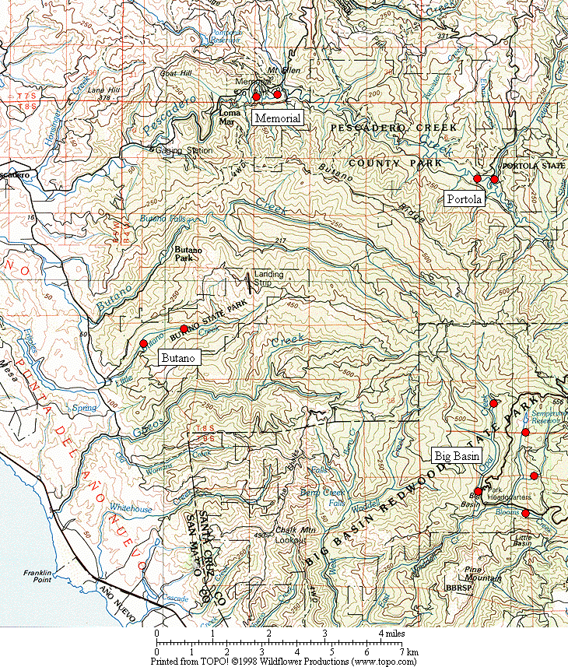

Figure 1. General location of the Marbled Murrelet monitoring stations in the four Santa Cruz Mountains parks.

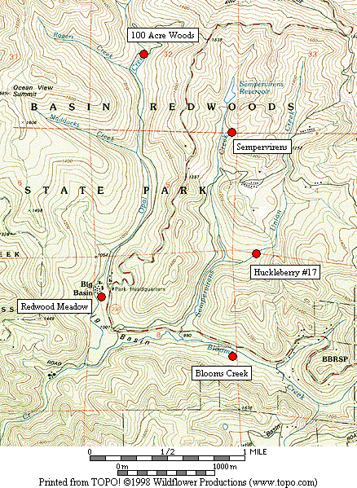

Figure 2. Location of Marbled Murrelet monitoring stations in Big Basin Redwoods State Park.

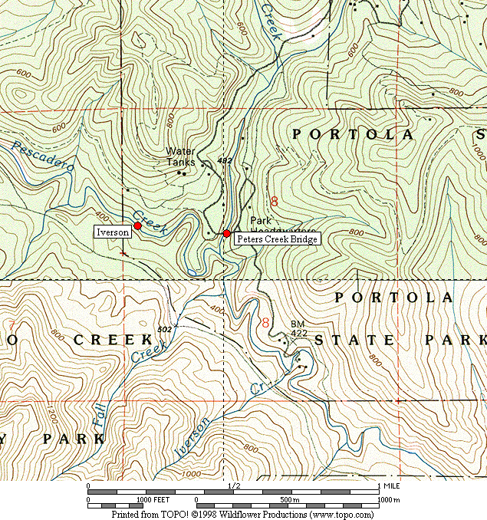

Figure 3. Location of Marbled Murrelet monitoring stations in Portola Redwoods State Park.

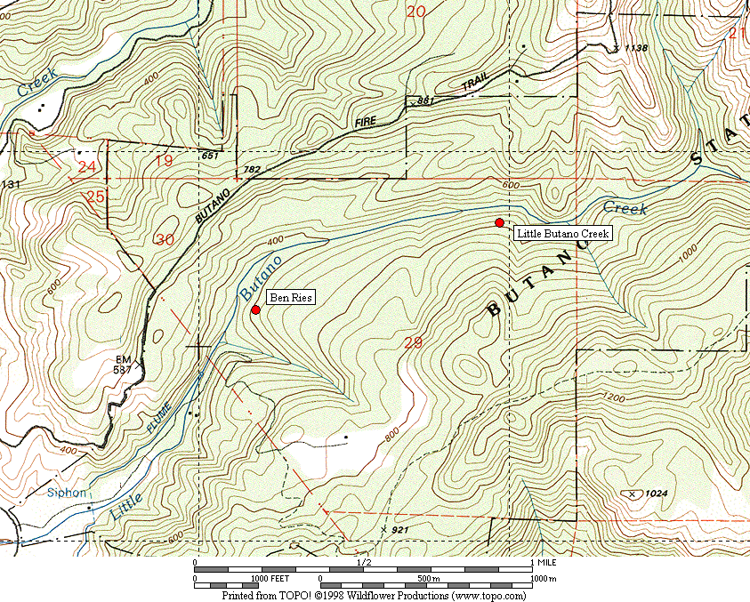

Figure 4. Location of Marbled Murrelet monitoring stations in Butano State Park.

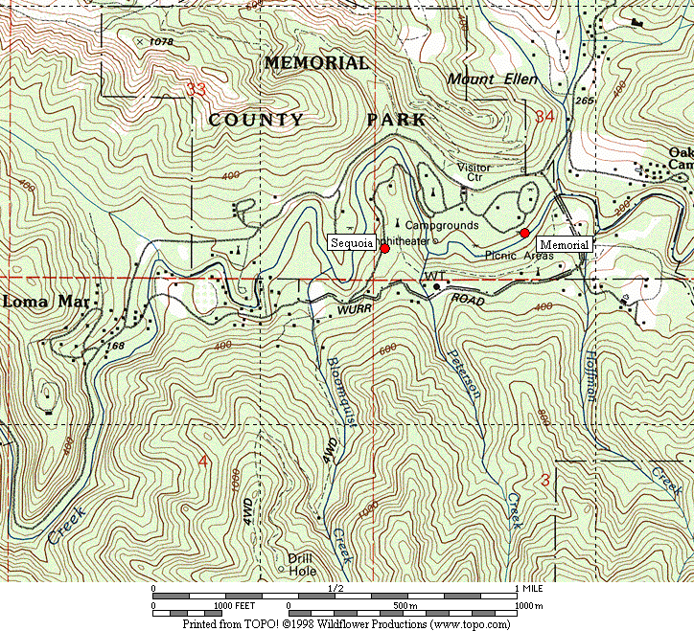

Figure 5. Location of Marbled Murrelet monitoring stations in San Mateo County Memorial Park.

Figure 6. Average murrelet activity on dawn surveys from all five Big Basin stations, 1995-2006. (Note: no data from 1997, 1999 or 2000.)

Figure 7. Average annual murrelet activity at all five Big Basin stations, showing total detections with polynomial regression trend, 1995-2006. (Note: no data from 1997, 1999 or 2000.)

A. “Redwood Meadow” B. “100 Acre Woods”

C. “Blooms Creek” D. “Huckleberry” (Note: no
detections were recorded in 2002)

E. “Sempervirens” (Note: no detections
were recorded in 2002 to 2006)

Figure 8. Annual activity levels (average total detections) at individual Big Basin monitoring stations from 1995 – 2006. (Note: no data for 1997, 1999 or 2000. See table 2 for standard deviations)
Figure 9. Average detections from dawn surveys on three consecutive mornings in late June or early July at “Peters Creek Bridge,” Portola Redwoods State Park, 1992-2006. (Note: no data from 1996, 1997, 1999, or 2000.)

Figure 10. Linear regression on average detections from dawn surveys on three consecutive mornings at “Peters Creek Bridge” in Portola Redwoods State Park, 1992 to 2006. (Note: no data from 1996, 1997, 1999, or 2000.)

Figure 11. Relative levels of Marbled Murrelet activity at each park in 2003 to 2006, showing total detections.

Figure 12. Relative levels of Marbled Murrelet activity at each park in 2003 to 2006, showing detections with occupied site behavior.

A. “Peters Creek Bridge”, Portola B. “Iverson”, Portola C. “Ben Ries”, Butano

D. “Little Butano Creek”, Butano E. “Memorial”, Memorial F. “Sequoia”, Memorial

Figure 13. Annual activity levels (average total detections) at individual monitoring stations from 2003-2006 at Portola, Butano and Memorial parks. (Note: scales for the y-axis vary; see table 2 for standard deviations)

32

- Individual Parks

- All Parks Combined

Figure 14. Average number of Steller’s Jays (A) per station in each park 2001-2006, and (B) in all parks combined 2003-2006. (Notes: Data from dawn murrelet surveys, using maximum count per year for each station. Jay numbers from 10-minute point counts. Only Big Basin stations were surveyed in 2001-2002).

A. Individual Parks

B. All Parks Combined

Figure 15. Average number of Common Ravens (A) per station in each park 2001-2006, and (B) in all parks combined 2003-2006. (Notes: Data from dawn murrelet surveys, using maximum count per year for each station. Raven numbers from 2-hour surveys. Only Big Basin stations were surveyed in 2001-2002).

Figure 16. Average detections for all parks combined in 2003-2006.
Appendix 1. Bird species detected and point count maxima from 2006 dawn Marbled Murrelet surveys. (See footnote for key to station codes.)¹

Big Basin Portola Butano Memorial

Species RM BC HU OA SP PC IV BR LB ME SQ

Wood Duck – – – – – – – – – 1 –
Common Merganser – – – – – 1 – – X X –
Sharp-shinned Hawk – – – – – – – – – 1 –
Cooper’s Hawk – 1 1 – 1 – – X X – –
Red-shouldered Hawk X 1 3 1 X 1 1 X X 2 2
Peregrine Falcon – – – – – – – – – 1³ X

Marbled Murrelet ⁴ 7 X X 2 – 7 5 5 11 3 4
Band-tailed Pigeon 6 6 3 2 3 2 1 2 4 4 4
Mourning Dove X 1 – – – X – – – – –
Barn Owl – – – – – – – X – – –
Western Screech-Owl X X – X – – – – – – –
Northern Pygmy-Owl – X – – – – – X – – –

Vaux’s Swift 1 – 1 – – 2 – – – – –
Allen’s Hummingbird 1 – 1 – – – 1 X 1 – 1
Belted Kingfisher – – – X – – – – – 1 –
Acorn Woodpecker 28 18 14 X 4 3 – 2 – 3 9
Red-breasted Sapsucker – 1 – – – – – – – – –
Hairy Woodpecker 1 2 X – 2 X – 2 X 1 1

Appendix 1, continued

Big Basin Portola Butano Memorial

Species RM BC HU OA SP PC IV BR LB ME SQ

Northern Flicker X 1 2 – 1 X – – – X X
Pileated Woodpecker 3 4 1 4 2 1 – 2 2 3 4
Pacific-slope Flycatcher 2 1 X 5 3 3 2 2 4 1 2
Black Phoebe – X – – – 1 – – – 1 1
Ash-throated Flycatcher – – – – X – – – – – –
Hutton’s Vireo 2 2 X X 2 1 – 1 – 2 X

Warbling Vireo – X – – – – 1 – 1 – –
Violet-green Swallow – – – – – 4 2 – 1 – X
Steller’s Jay 8 11 27 2 4 4 2 10 5 9 14
Common Raven 1 4 5 2 2 1 – 2 X 6 3
Chestnut-backed Chickadee 6 4 4 2 4 2 4 5 6 5 4
Pygmy Nuthatch 3 7 2 1 2 4 4 3 X 3 5

Brown Creeper 3 1 3 3 3 3 2 3 2 3 3
Winter Wren 1 2 3 2 2 1 3 4 3 3 3
American Dipper – – – – – 1 – – – 1 –
Golden-crowned Kinglet 1 X 1 2 X 1 1 2 2 1 –
Hermit Thrush 1 3 3 1 1 – 1 – – – –
Swainson’s Thrush 2 – – – – 1 1 1 – 2 X

Appendix 1, continued

Big Basin Portola Butano Memorial

Species RM BC HU OA SP PC IV BR LB ME SQ

American Robin 4 2 1 X 1 2 1 4 1 2 4
Varied Thrush – – – 1 – – – – – – –
Wrentit 1 – – 1 – 1 X – – – –
Wilson’s Warbler 2 3 – – – 1 2 1 2 1 1
Spotted Towhee 1 4 4 – – X – – – – –

Black-headed Grosbeak X – X – – – – – – – –
Dark-eyed Junco 3 – 1 2 2 2 1 – – 2 1
Purple Finch X 1 1 – – – 1 2 1 – –
Pine Siskin – – – – – – – 1 1 1 1

1. Station codes: RM (Redwood Meadow), BC (Blooms Creek), HU (Huckleberry #17), OA (100 Acre Woods), SP (Sempervirens), PC (Peters Creek
Bridge), IV (Iverson Trail), BR (Ben Ries), LB (Little Butano Creek), ME (Memorial), SQ (Sequoia).
2. “X” denotes a species detected during a 2-hour survey, but not detected during any point count.
3. Three dependant juvenile Peregrine Falcons were also detected, but are not included in the tally here.
4. Number given for Marbled Murrelet is the best estimate from one or more detections during a point count.
Appendix 2. Comprehensive Summary of Dawn Marbled Murrelet Surveys at Redwood Meadow / Park Headquarters Area in Big Basin Redwoods State Park 1991-2006.

In addition to the 35 dawn surveys conducted at Redwood Meadow specifically for the California Dept. of Fish and Game (1995-2002) and the COSTC (2003-2006), Suddjian conducted 151 additional surveys from 1991-2006 at Redwood Meadow and the adjacent parking lot at Park Headquarters, for a total of 186 dawn surveys conducted there over the 16 year period (91% by Suddjian). In 2006 Suddjian conducted 16 additional surveys at the Redwood Meadow / Park Headquarters parking lot area from April 19 to July 23, beyond the three called for by COSTC contract, for 19 total surveys in 2006. An average of 11.6 dawn surveys (range 6-19 surveys) have been conducted annually, with 16-19 per year since 2002 (Figure 2-1).

The meadow and parking lot are 70 meters apart, and both offer an expansive view of the sky. Surveys in both spots sample largely the same activity, and auditory and some visual detections overlap broadly between the two stations (D. Suddjian pers. obs.). Thus, survey results from these adjacent spots are combined here to provide a long-term trend in murrelet activity in the park headquarters area. Additionally, the surveys span April to July, and so sample a broader portion of the murrelet nesting season than the current COSTC monitoring scheme.

Murrelet activity in 2006 remained very low at Redwood Meadow / Park Headquarters compared to activity in the early 1990s (Figures 2-2 and 2-3), with a highly significant declining trend evident for total detections (r² = 0.944, P <0.0001) and those with occupied site behavior (r² = 0.964, P <0.0001). Activity levels in 2006 remained at a continued low ebb that was first approached in 2002. However, even at a low ebb, activity has actually continued to decline over 2002-2006 (Figure 2-4). Surveys in 2006 included seven mornings with zero detections, including one in late June, historically a very active period. Annual medians, maxima, and minima have exhibited the same pattern, with the median values quite close to the minima since 2001 (Figure 2-5). Maxima have varied widely, but show the same declining trend over the 16-year period and have seemingly reached an ebb in the last few years (Figure 2-5). Average total detections have declined annually in each of the four months from April to July (Figure 2-6). The typical seasonal activity peak expected in July has only occurred in one year since 2001 (Figure 2-6).

Figure 2-1. Number of dawn surveys conducted annually at the Redwood
Meadow / Park Headquarters area in Big Basin from 1991-2006.

Figure 2-2. Average number of total detections (± s.d) on dawn surveys at Redwood
Meadow / Park Headquarters, 1991-2006. (Note: see Figure 2-1 for annual sample
sizes. Surveys occurred between April 5 and July 31 each year.)

Figure 2-3. Average number of occupied behavior detections (± s.d) on dawn
surveys at Redwood Meadow / Park Headquarters, 1991-2006. (Note: see Figure
2-1 for annual sample sizes. Surveys occurred between April 5 and July 31 each year.)

Figure 2-4. Average number of detections on dawn surveys at Redwood
Meadow / Park Headquarters for 1998-2006 (Note: see Figures 2-2 and 2-3 standard deviations.)

Figure 2-5. Annual median, maximum and minimum total detections on dawn
surveys at Redwood Meadow / Park Headquarters in Big Basin, 1991-2006.

Figure 2-6. Monthly average number of detections on dawn surveys at Redwood Meadow / Park Headquarters in Big Basin, 1991-2006.

Appendix 3. Summary of Marbled Murrelet Detections During Coverage of a Breeding Bird Survey in Big Basin Redwoods State Park, 1992-2006.

The “Pescadero, CA” route (#14-319) is part of the USGS’s Breeding Bird Survey (BBS). The route begins in Big Basin just west of Blooms Creek Campground, and proceeds (via Gazos Creek Road, Cloverdale Road, and Pescadero Road) for 24.5 miles to San Mateo County Memorial Park. Birds are surveyed for three minutes at stops located every 0.5 mile. The route passes through various areas of suitable Marbled Murrelet habitat, but over this route’s history murrelets were only detected at the first 10 stops (Figure 3-1); the remaining areas of suitable habitat are not surveyed until after flight activity has ceased for the morning.

Suddjian initiated the “Pescadero, CA” BBS route in 1992, and has sampled it in most years since then. Each survey has occurred between May 29 and June 1. Official results for 1992-1997, and 2001-2006 are available at < http://www.pwrc.usgs.gov/bbs/ >. The route could not be covered in its entirety during 1998-2000 due to road washouts and problems with access through a gate along Gazos Creek Road. But in all years except 2000 Suddjian at least surveyed the beginning portion of the route in Big Basin, including all the stops where murrelet activity has been recorded (Figure 3-1).

While the BBS method is not specifically designed for monitoring murrelets at forest sites, it does provide a repeated measure of murrelet activity, and coverage for the BBS at Big Basin was contemporaneous with the other monitoring efforts presented in this report. The first three stops at the very beginning of the route (Figure 3-1) are located in the East Waddell / Opal Creek watersheds in areas that through the early 1990s had very high levels of activity.

Murrelet activity recorded on the “Pescadero, CA” BBS route exhibited a pattern of decline from 1992 – 2006 that closely paralleled the decline recorded by the other Big Basin monitoring efforts (see Figure 7 and Appendix 2). Three related measures – (1) total detections, (2) total estimated individuals, and (3) the number of stops where murrelets were recorded – all showed the same pattern. The number of detections showed a highly significant declining trend (r² = 0.697, P = 0.0001).

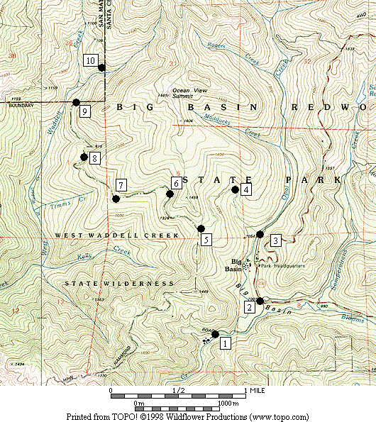

Figure 3-1. Stops on the Breeding Bird Survey route “Pescadero, CA” (#14-319) where Marbled Murrelets were detected on surveys in 1992-2006.

Figure 3-2. Marbled Murrelet activity recorded within Big Basin Redwoods State Park on the "Pescadero, CA” Breeding Bird Survey route in 1992 to 2006. (Note: No data for 2000.)

